**TEAM ID - PNT2022TMID43140**

**Corporate Employee Attrition Analytics**

**1. INDRODUCTION**

**1.1 Project Description**

Employee is the most important human capital asset who results to reflect the success of organization. The brunt of globalization has resulted to mobilization of workforce from one organization to another, region to region and sometime from one country to another. Hence, it has become greatest challenge for HR manager to handle the loss of skilled employee’s attrition. In HR practice, the term  
Employee Turnover and Attrition are interchangeable with respect to industry its causes. Attrition means reduction of employee through retirement, resignation, or death. Employee Attrition is serious issue that addresses the voluntary or forceful termination of talent and skilled employee, which affects the goodwill and productivity of organization. Employee Attrition can be indicated that employees are leaving due work related or personal problem. In most of the research it has been found that work related in the major cause for higher employee attrition rate High attrition result to loss on the cost of company spent on recruitment and training. The impact of employee attrition leaves a long term negative  
impression on goodwill of organization. In simple words, it can said that employee attrition is caused due to non fulfillment of employee’s perception or expectation towards employer or failure of employer’s commitment towards employees satisfaction .

**1.2 Project Purpose**

In currently a day’s worker Attrition prediction become a serious drawback within the organizations. worker Attrition may be a huge organizations specially once trained, technical and key workers leave for a much better chance from the organization. This leads to loss to interchange a trained worker. Therefore, we tend to use this and past worker knowledge to research the common reasons for worker attrition or attrition.

**2. LITERATURE SURVEY**

**2.1 Existing problem**

well-trained and well-adapted employee leaves the organization, it creates a vacuum. The paper aims at identifying factors affecting employee attrition like, growth opportunities, work environment, business travel opportunities, superior – subordinate relationship, recognition and appreciation, years since last promotion etc. These factors would then be used to predict employee attrition. This prediction would help in retaining valuable employees by providing incentive

**2.2 References**

[01] Sandeep Yadav, Aman Jain, Deepti Singh, “Early Prediction of Employee Attrition using DataMining Techniques” in IEEE 2018.

[02] R Shiva Shankar, J Rajanikanth, V.V.Sivaramaraju, K VSSR Murthy, ” PREDICTION OFEMPLOYEE ATTRITION USING DATAMINING”, in IEEE

[03] Rachna Jain, Anand Nayyar,” Predicting Employee Attrition using XGBoost Machine Learning Approach”, in IEEE 2018

[04] Sarah S. Alduayj, Kashif Rajpoot, “Predicting Employee Attrition using Machine Learning”,in IEEE 2018.

[5] Nagadevara, Vishnuprasad. (2018). Early Prediction of Employee Attrition in Software Companies Application of Data Mining Techniques.

**2.3 Problem Statement Definition**

Attrition is critical in the industry these days. It’s the major problem which highlights in all the organizations. “Attrition is said to be the gradual reduction in the number of employees through retirement, resignation or death. It can also be said as Employee Turnover or Employee Defection” A well- trained and well adapted employee leaves the organization, it creates a vacuum. So, the organization loses key skills, knowledge and business relationships.

**3.IDEATION & PROPOSED SOLUTION**

**3.1 Empathy Map Canvas**

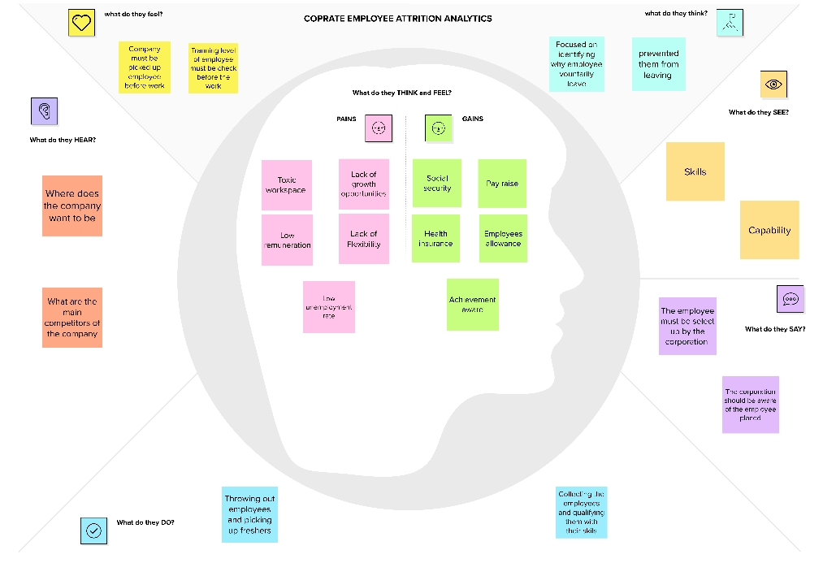

**3.2 Ideation & Brainstorming**

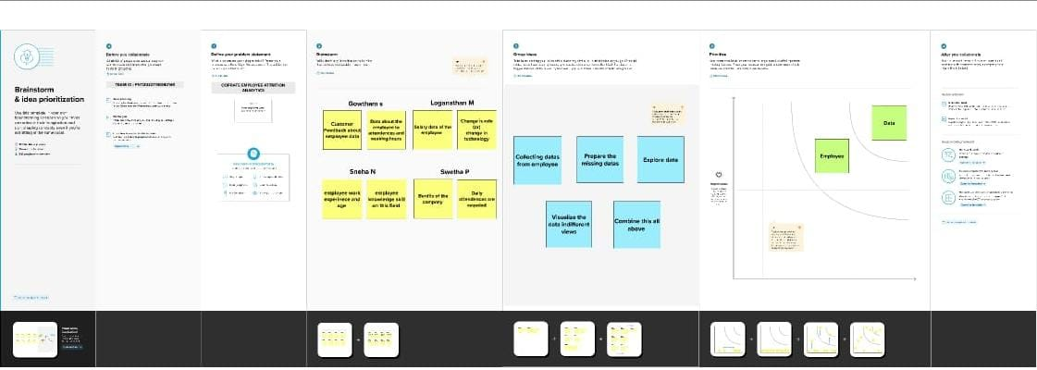

**3.3 Proposed Solution**

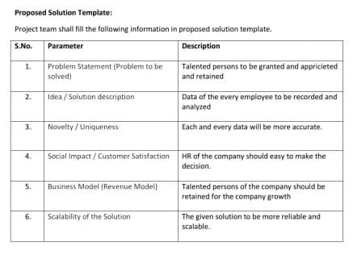

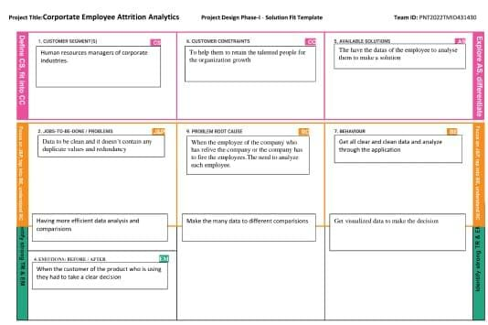**3.4 Problem Solution Fit**

**4. REQUIREMENT ANALYSIS**

**4.1 Functional Requirement**

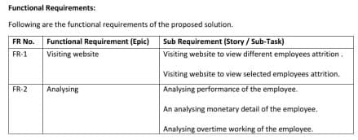

**4.2 Non – Functional Requirement**

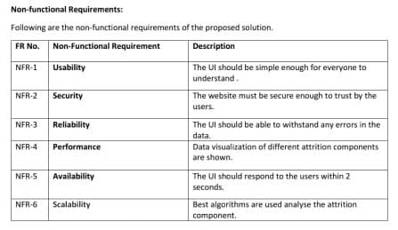

**5.PROJECT DESIGN**

**5.1 Data Flow Diagram**

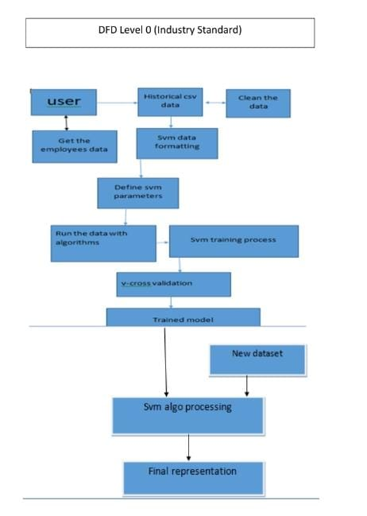

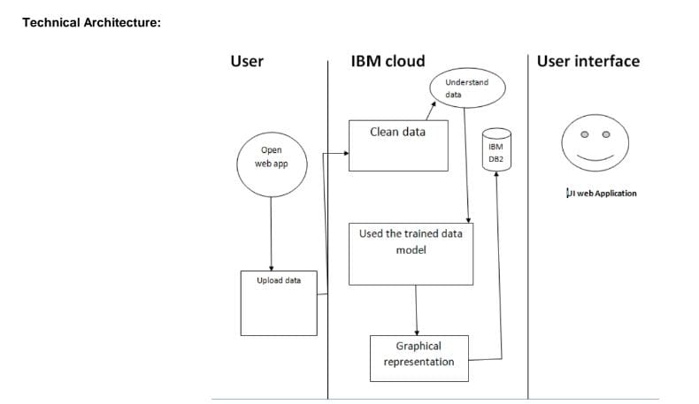**5.2 Solution &Technical Architecture**

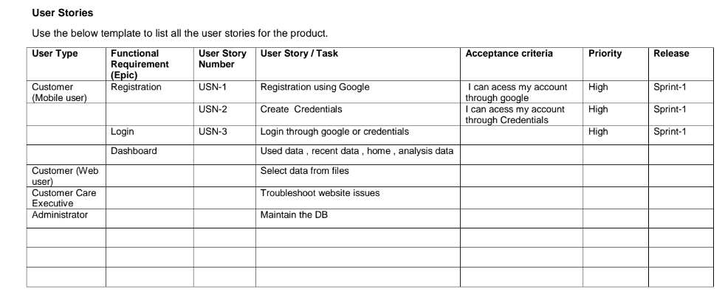**5.3 User Stories**

**6. PROJECT PLANNING & SCHEDULING**

**6.1 Sprint Planning & Estimation**

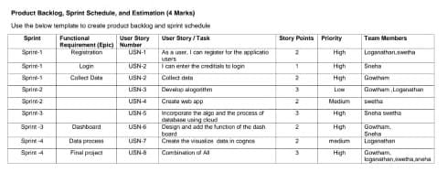

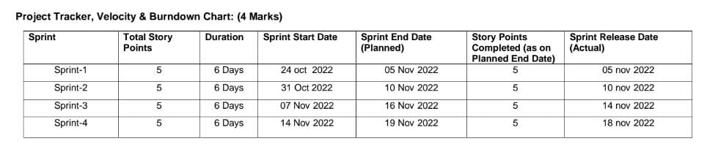**6.2 Sprint Delivery Schedule**

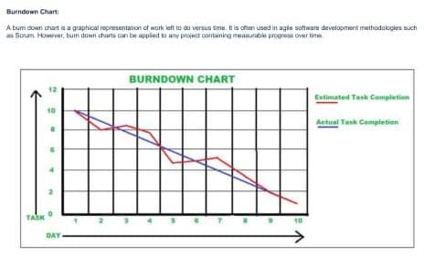**6.3 Report from Jira**

**7. CODING & SOLUTIONING**

**Employee Attrtion with ml deployment:**

<!DOCTYPE html>

<html >

<head>

<meta charset="UTF-8">

<title>Employee Attrition Prediction</title>

<link href='https://fonts.googleapis.com/css?family=Pacifico' rel='stylesheet' type='text/css'>

<link href='https://fonts.googleapis.com/css?family=Arimo' rel='stylesheet' type='text/css'>

<link href='https://fonts.googleapis.com/css?family=Hind:300' rel='stylesheet' type='text/css'>

<link href='https://fonts.googleapis.com/css?family=Open+Sans+Condensed:300' rel='stylesheet' type='text/css'>

</head>

<body>

<div class="login">

<h1>Predict Attrition</h1>

<!-- Main Input For Receiving Query to our ML -->

<form action="{{ url_for('predict')}}" method="POST" autocomplete="on">

<strong>Age</strong> : <input type="number" name="Age" placeholder="18-80" required min="18" max="80"><br><br>

<strong>BusinessTravel</strong> : <input type="radio" name="BusinessTravel" id="Rarely" value="Rarely">Rarely <input type="radio" name="BusinessTravel" id="Frequently" value="Frequently"> Frequently<input type="radio" name="BusinessTravel" id="No Travel" value="No Travel">No Travel<br><br>

<strong>Daily Rate</strong> : <input type="number" name="Daily Rate" placeholder="100-1600" required min="100" max="1600" size="30"><br><br>

<strong>Department</strong> :<input type="radio" name="Department" id="Research & Development" value="Research & Development">Research & Development <input type="radio" name="Department" id="Human Resources" value="Human Resources">Human Resources <input type="radio" name="Department" id="Sales" value="Sales">Sales<br><br>

<strong>Distance From Home</strong> : <input type="number" name="Distance From Home" placeholder="1-29" required min="1" max="29"><br><br>

<strong>Education</strong> : <input type="number" name="Education" placeholder="1-5" required min="1" max="5"><br><br>

<strong>Education Field</strong> : <input type="radio" name="Education Field" id="Life Sciences" value="Life Sciences">Life Sciences <input type="radio" name="Education Field" id="Medical" value="Medical">Medical <input type="radio" name="Education Field" id="Marketing" value="Marketing">Marketing <input type="radio" name="Education Field" id="Technical Degree" value="Technical Degree">Technical Degree <input type="radio" name="Education Field" id="Human Resources" value="Human Resources">Human Resources <input type="radio" name="Education Field" id="Other" value="Other">Other <br><br>

<strong>Environment Satisfaction</strong> : <input type="number" name="Environment Satisfaction" placeholder="1-4" required min="1" max="4"><br><br>

<strong>Gender</strong> : <input type="radio" name="Gender" id="Male" value="Male">Male <input type="radio" name="Gender" id="Female" value="Female">Female<br><br>

<strong>Hourly Rate</strong> : <input type="number" name="Hourly Rate" placeholder="30-100" required min="30" max="100"><br><br>

<strong>Job Involvement</strong> : <input type="number" name="Job Involvement" placeholder="1-4" required min="1" max="4"><br><br>

<strong>Job Level</strong> : <input type="number" name="Job Level" placeholder="1-5" required min="1" max="5"><br><br>

<strong>Job Role</strong> : <input type="radio" name="Job Role" id="Sales Executive" value="Sales Executives">Sales Executive <input type="radio" name="Job Role" id="Research Scientist" value="Research Scientist">Research Scientist <input type="radio" name="Job Role" id="Laboratory Technician" value="Laboratory Technician">Laboratory Technician <input type="radio" name="Job Role" id="Manufacturing Director" value="Manufacturing Director">Manufacturing Director <input type="radio" name="Job Role" id="Healthcare Representative" value="Healthcare Representative">Healthcare Representative <input type="radio" name="Job Role" id="Manager" value="Manager">Manager <input type="radio" name="Job Role" id="Sales Representative" value="Sales Representative">Sales Representative <input type="radio" name="Job Role" id="Research Director" value="Research Director">Research Director <input type="radio" name="Job Role" id="Human Resource" value="Human Resources">Human Resources <br><br>

<strong>Job Satisfaction</strong> : <input type="number" name="Job Satisfaction" placeholder="1-4" required min="1" max="4"><br><br>

<strong>Marital Status</strong> : <input type="radio" name="Marital Status" id="Married" value="Married">Married <input type="radio" name="Marital Status" id="Single" value="Single">Single <input type="radio" name="Marital Status" id="Divorced" value="Divorced">Divorced<br><br>

<strong>Monthly Income</strong> : <input type="number" name="Monthly Income" placeholder="1000-20000" required min="1000" max="20000" size="30"> (1000-20000)<br><br>

<strong>Number of Companies Worked in</strong> : <input type="number" name="Number of Companies Worked in" placeholder="0-9" required min="1" max="9"><br><br>

<strong>Over Time</strong> : <input type="radio" name="Over Time" id="Yes" value="Yes">Yes <input type="radio" name="Over Time" id="No" value="No">No<br><br>

<strong>Performance Rating</strong> : <input type="number" name="Performance Rating" placeholder="1-4" required min="1" max="4"><br><br>

<strong>Relationship Satisfaction</strong> : <input type="number" name="Relationship Satisfaction" placeholder="1-4" required min="1" max="4"><br><br>

<strong>Stock Option Level</strong> : <input type="number" name="Stock Option Level" placeholder="0-3" required min="0" max="3"><br><br>

<strong>Total Working Years</strong> : <input type="number" name="Total Working Years" placeholder="0-40" required min="0" max="40"><br><br>

<strong>Training Times Last Year</strong> : <input type="number" name="Training Times Last Year" placeholder="0-6" required min="0" max="6"><br><br>

<strong>Work Life Balance</strong> : <input type="number" name="Work Life Balance" placeholder="1-4" required min="1" max="4"><br><br>

<strong>Years At Company</strong> : <input type="number" name="Years At Company" placeholder="0-40" required min="0" max="40"><br><br>

<strong>Years In Current Role</strong> : <input type="number" name="Years In Current Role" placeholder="0-18" required min="0" max="18"><br><br>

<strong>Years Since Last Promotion</strong> : <input type="number" name="Years Since Last Promotion" placeholder="0-15" required min="0" max="15"><br><br>

<strong>Years With Curr Manager</strong> : <input type="number" name="Years With Curr Manager" placeholder="0-17" required min="0" max="17"><br><br>

<br><button type="submit" class="btn btn-primary btn-block btn-large">Predict</button>

</form>

<br>

<br>

<h1>{{ prediction_text }}</h1>

</div>

</body>

</html>

**Dashboard.html**

<!doctype html>

<!-- Website template by freewebsitetemplates.com -->

<html>

<head>

<meta charset="UTF-8">

<meta name="viewport" content="width=device-width, initial-scale=1.0">

<title>Data Analytics</title>

<link rel="stylesheet" href="css/style.css" type="text/css">

<link rel="stylesheet" type="text/css" href="css/mobile.css">

<script src="js/mobile.js" type="text/javascript"></script>

<meta name="viewport" content="width=device-width, initial-scale=1">

<style>

* {box-sizing: border-box;}

body {font-family: Verdana, sans-serif;}

.mySlides {display: none;}

img {vertical-align: middle;}

/* Slideshow container */

.slideshow-container {

max-width: 1000px;

position: relative;

margin: auto;

}

/* Caption text */

.text {

color: #f2f2f2;

font-size: 15px;

padding: 8px 12px;

position: absolute;

bottom: 8px;

width: 100%;

text-align: center;

}

/* Number text (1/3 etc) */

.numbertext {

color: #f2f2f2;

font-size: 12px;

padding: 8px 12px;

position: absolute;

top: 0;

}

/* The dots/bullets/indicators */

.dot {

height: 15px;

width: 15px;

margin: 0 2px;

background-color: #bbb;

border-radius: 50%;

display: inline-block;

transition: background-color 0.6s ease;

}

.active {

background-color: #717171;

}

/* Fading animation */

.fade {

animation-name: fade;

animation-duration: 1.5s;

}

@keyframes fade {

from {opacity: .4}

to {opacity: 1}

}

/* On smaller screens, decrease text size */

@media only screen and (max-width: 300px) {

.text {font-size: 11px}

}

</style>

</head>

<body>

<div id="body">

<div class="header">

<div>

<h1>DATA ANALYTICS</h1>

</div>

</div>

<div class="blog">

<div class="featured">

<ul>

<h2>Sample images</h2>

<p>Analysis in cognos</p>

<div class="slideshow-container">

<div class="mySlides fade">

<div class="numbertext">1 / 3</div>

<img src="img1.png" width="700" height="700">

<div class="text">Caption Text</div>

</div>

<div class="mySlides fade">

<div class="numbertext">2 / 3</div>

<img src="img2.png" width="700" height="700">

<div class="text">Caption Two</div>

</div>

<div class="mySlides fade">

<div class="numbertext">3 / 3</div>

<img src="img3.png" width="700" height="700">

<div class="text">Caption Three</div>

</div>

</div>

<br>

<div style="text-align:center">

<span class="dot"></span>

<span class="dot"></span>

<span class="dot"></span>

</div>

<script>

let slideIndex = 0;

showSlides();

function showSlides() {

let i;

let slides = document.getElementsByClassName("mySlides");

let dots = document.getElementsByClassName("dot");

for (i = 0; i < slides.length; i++) {

slides[i].style.display = "none";

}

slideIndex++;

if (slideIndex > slides.length) {slideIndex = 1}

for (i = 0; i < dots.length; i++) {

dots[i].className = dots[i].className.replace(" active", "");

}

slides[slideIndex-1].style.display = "block";

dots[slideIndex-1].className += " active";

setTimeout(showSlides, 3000); // Change image every 2 seconds

}

</script>

<li>

<div>

<h1>DATA ANALYTICS BY IBM COGNOS</h1>

<p>WE CAN SEE THE DASH BOARD BY CLICKING THESE AND LOGON TO COGNOS</p>

<a href="https://login.ibm.com/authsvc/mtfim/sps/authsvc?PolicyId=urn:ibm:security:authentication:asf:basicldapuser&Target=https%3A%2F%2Flogin.ibm.com%2Foidc%2Fendpoint%2Fdefault%2Fauthorize%3FqsId%3Dbcb0d44a-9f2d-48cf-bb43-311c1b29486d%26client_id%3DMyIBMLondonProdCI" class="more">VIEW DASHBOARD</a>

</div>

</li>

<li>

<div>

<h1>SAMPLES OF THE IBM COGNOS</h1>

<iframe src="https://us1.ca.analytics.ibm.com/bi/?perspective=dashboard&amp;pathRef=.my_folders%2FPharma%2BDashboard&amp;closeWindowOnLastView=true&amp;ui_appbar=false&amp;ui_navbar=false&amp;shareMode=embedded&amp;action=view&amp;mode=dashboard&amp;subView=model00000183829e6992_00000000" width="320" height="200" frameborder="0" gesture="media" allow="encrypted-media" allowfullscreen=""></iframe>

</div>

</li>

</ul>

</div>

</div>

</div>

<div id="footer">

<div>

<div class="connect">

<a href="http://facebook.com/" class="facebook">facebook</a>

<a href="http://twitter.com/" class="twitter">twitter</a>

<a href="http://googleplus.com/" class="googleplus">googleplus</a>

<a href="http://pinterest.com" class="pinterest">pinterest</a>

</div>

<p>&copy; 2023 Employee attrtion. All Rights Reserved.</p>

</div>

</div>

</div>

</body>

</html>

**8. TESTING**

**8.1 Acceptance testing:**



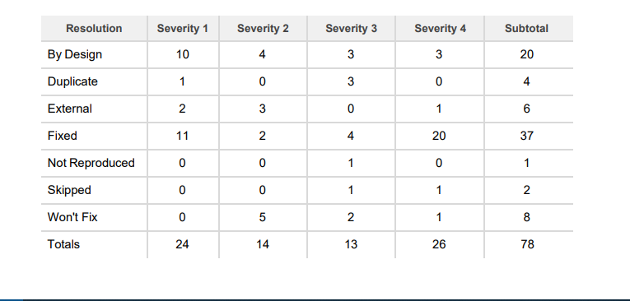**8.2 User Acceptance Testing:**

**9. RESULTS**

**9.1 Performance metrics:**

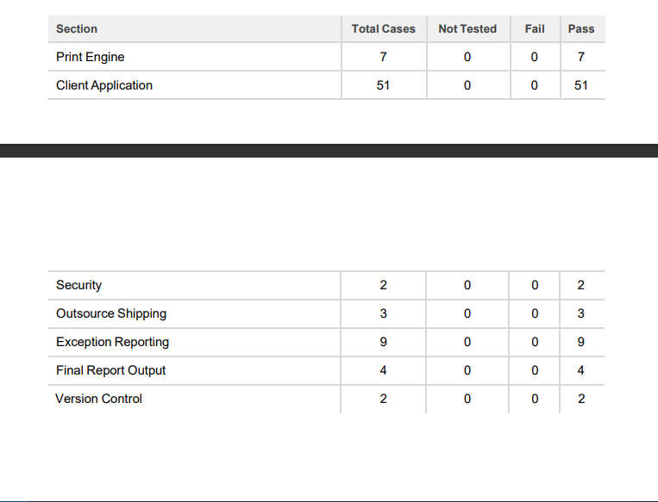

**10. ADVANTAGES AND DISADVANTAGES**

**10.1 Advantages:**

* Toxic workspace
* Lack of opportunities
* Low remuneration
* Lack of flexibility
* Low un employment rate

**10.2 Disadvantages:**

* Social security
* Pay raise
* Health insurance
* Employee allowance
* Achievement award

**11. CONCLUSION**

Retention of talent and skilled employee is crucial dilemma for HR Manager especially in manufacturing industry. This study has identified those complex factors which are key responsible for employee attrition in selected organization. The education and experience of employee creates opportunity for new job in market and it helps to enhance better career opportunity. The ethical work culture, cordial employee relation and implementation of organizational policies are the most attractive area of making employee to stay back in organization.

**12. FUTURE SCOPE**

No career growth or development opportunities: Global Talent Monitor's report on workforce activity shows that the lack of future career development remains a key driver of employee attrition — 40% of departing employees say it led them to be dissatisfied with their jobs, Gallup reports

**13. APPENDIX**

**13.1 GitHub Account Link**

https://github.com/IBM-EPBL/IBM-Project-37941-1660365518

**13.2 Project Demo Link**

https://drive.google.com/file/d/1yu3Yxnye-WrpHdnOsUnr7H2RiT71mT0s/view?usp=sharing